Event Risk Assessment Template
A Risk Assessment is mandatory for events held on council land.
Conducting a Risk Assessment prior to an event means potential risks can be identified and rated according to probability of occurrence and severity of damages. Controls and actions can then be implemented to help reduce any potential risks prior to the event taking place.
While the most effective way of managing risk is to eliminate the hazard, the following Hierarchy of Controls shows other options available. Administrative controls could include staff training or the use of signage and warning labels. Personal Protective Equipment could be used such as high visibility clothing, sun/rain protection, hard hats, safety glasses, and appropriate footwear.

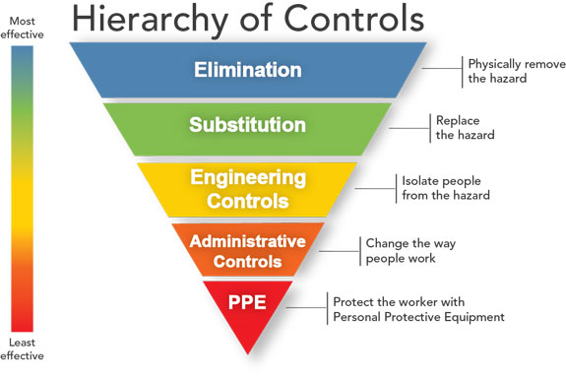

Note that each hazard/risk may require more than one control. E.g., an extreme heat day may require engineering controls, administrative controls and PPE to minimise risks of illness/injury on the day.

CALCULATING RISK RATING

Likelihood x Consequence = Risk Rating

LIKELIHOOD  Level Descriptor Detail description  A Almost certain Expected to occur in most circumstances  B Likely Once per year  C Moderate Possible, once in 10 year period  D Unlikely Not impossible, within 50 years  E Rare Unlikely within 50 years | CONSEQUENCE  Level Descriptor Detail description  1 Insignificant Near miss injury, low loss  2 Minor First aid, medium loss  3 Moderate Treatment required, high loss  4 Major Extensive injuries, major loss  5 Catastrophic Death, huge loss

RISK RATING MATRIX
 |  | CONSEQUENCE
LIKELIHOOD | 5 - Catastrophic | 4 - Major | 3 - Moderate | 2 - Minor | 1 - Insignificant
A - Almost Certain | Extreme | Extreme | High | High | Medium
B - Likely | Extreme | High | High | Medium | Medium
C - Moderate | High | High | High | Medium | Low
D - Unlikely | High | Medium | Medium | Low | Low
E - Rare | High | Medium | Medium | Low | Low

Example Event Risk Types / Possible Controls

Environmental  - Severe Weather Warning  - Lightning storms  - Flash flooding, heavy downpours, hailstorms  - Landslide  - Damaging winds  - Bushfire / grassfire, declared Total Fire Ban Day, Fire Danger Rating of Extreme or Catastrophic  - Heatwave  - Dust storm  - Damage to native fauna, flora & waterways | Building structures  - Building access and exit points signposted.  - Emergency assembly areas signposted.  - Pedestrian/people traffic management and flow  - Night-time lighting/security lighting  - Up to date fire suppression equipment in the building  - Building emergency/evacuation plan on display  - Building maximum people capacity, building weight capacity (two storey)  - Toilet facilities in relation to people numbers  - Marquee, tent structures and anchorage  - Building electrical equipment. Circuit breakers, leads.  - Testing and tagging of electrical items | Temporary structures/staging  - Use of accredited construction contractors, SWMS’s, JSA’s  - Trip hazards, ladders  - Electrical installation, power boards, leads.  - Test and tag electrical items  - Signage, barricades, portable fire equipment  - Gas cylinders/testing for leaks  - Heaters and fire bucket location to flammable objects  - Night-time lighting/security  - Working at heights  - Scaffolding  - Slip & trip hazards identified and eliminated or controlled.
Food safety  - Food and health safety standards  - Staff/volunteers trained in food handling.  - Food, water, drinks contamination; food poisoning  - Alcohol on site - alcohol limits, types of drinking containers  - Permits in place from council health officer.  - Certificates/permits displayed. | Security & Emergency Services  - Pickpockets, goods theft, plant theft  - Vandalism to buildings, plant, and equipment  - Public order (crowd control)  - Vehicle Borne Attacks  - Drugs management  - Liquor licensing  - Emergency Services notified & available if required.  - Emergency Services contact number and Event Organiser contact numbers on display/available | Road closures / public road use / public numbers  - Traffic/pedestrian management  - Road and pathway use/blockages/closures  - Vehicle and participant numbers  - Road/pathway signage  - Road permits/notifications (VicRoads/council)
Financial  - Profit of break-even cost  - Net loss  - Public liability insurance claim  - Property damage claim | Public Liability Insurance & Licenses  - Stall holders to have own public liability insurance.  - Contractors accredited and insured.  - Contractors provide JSAs & SWMS  - Food sellers trained and accredited. | Health & Safety  - First Aid/defibrillator facilities on site  - Accredited First Aid staff on site.  - Fire suppression equipment on site  - SWMS & Working at Heights Certificates if required

Event Risk Assessment Template
Note that all other event details (including date, time, location, number of attendees) should have been provided in the event registration form.
A Risk Assessment is mandatory for events held on council land.
Event name
Event description
Event contact (name / email / phone)

Issue/Hazard | What are the risks? | What is currently being done to control the risk? | Likelihood | Consequence | Risk Rating | What further controls are required? | Control to be implemented by Who? When?
Example only:  Inclement weather | Attendees’ exposure to cold and wet conditions. | Monitoring weather forecasting websites leading up to the event. | B | 2 | MEDIUM | Contingency planning, i.e. adequate shelter for attendees. | Event manager  Date

Issue/Hazard | What are the risks? | What is currently being done to control the risk? | Likelihood | Consequence | Risk Rating | What further controls are required? | Control to be implemented by Who? When?

Issue/Hazard | What are the risks? | What is currently being done to control the risk? | Likelihood | Consequence | Risk Rating | What further controls are required? | Control to be implemented by Who? When?

Issue/Hazard | What are the risks? | What is currently being done to control the risk? | Likelihood | Consequence | Risk Rating | What further controls are required? | Control to be implemented by Who? When?

