Event Risk Management
Conducting a Risk Assessment prior to an event means potential risks can be identified and rated according to probability of occurrence and severity of damages. Controls and actions can then be implemented to help reduce any potential risks prior to the event taking place.
While the most effective way of managing risk is to eliminate the hazard, the following Hierarchy of Controls shows other options available. Administrative controls could include staff training or the use of signage and warning labels. Personal Protective Equipment could be used such as high visibility clothing, sun/rain protection, hard hats, safety glasses, and appropriate footwear.

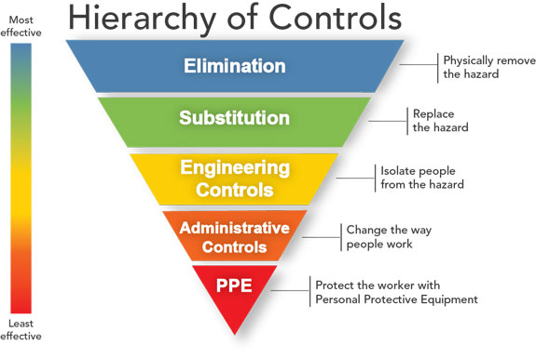

Note that each hazard/risk may require more than one control. E.g. an extreme heat day may require engineering controls, administrative controls and PPE to minimise risks of illness/injury on the day.

CALCULATING RISK RATING

Likelihood x Consequence = Risk Rating

 |  | LIKELIHOOD
Level | Descriptor | Detail description
A | Almost certain | Expected to occur in most circumstances
B | Likely | Once per year
C | Moderate | Possible, once in 10 year period
D | Unlikely | Not impossible, within 50 years
E | Rare | Unlikely within 50 years

 |  | CONSEQUENCE
Level | Descriptor | Detail description
1 | Insignificant | Near miss injury, low loss
2 | Minor | First aid, medium loss
3 | Moderate | Treatment required, high loss
4 | Major | Extensive injuries, major loss
5 | Catastrophic | Death, huge loss

RISK RATING MATRIX
 |  | CONSEQUENCE
LIKELIHOOD | 5 - Catastrophic | 4 - Major | 3 - Moderate | 2 - Minor | 1 - Insignificant
A - Almost Certain | Extreme | Extreme | High | High | Medium
B - Likely | Extreme | High | High | Medium | Medium
C - Moderate | High | High | High | Medium | Low
D - Unlikely | High | Medium | Medium | Low | Low
E - Rare | High | Medium | Medium | Low | Low
Example Event Risk Types / Possible Controls

Environmental  - Severe Weather Warning  - Lightning storms  - Flash flooding, heavy downpours, hail storms  - Landslide  - Damaging winds  - Bushfire, declared Total Fire Ban day, Fire Danger Rating of Severe or Code Red  - Heatwave  - Dust storm  - Damage to native fauna, flora & waterways | Building structures  - Building access and exit points signposted  - Emergency assembly areas signposted  - Pedestrian/people traffic management and flow  - Night-time lighting/security lighting  - Up to date fire suppression equipment in the building  - Building emergency/evacuation plan on display  - Building maximum people capacity, building weight capacity (two storey)  - Toilet facilities in relation to people numbers  - Marquee, tent structures and anchorage  - Building electrical equipment. Circuit breakers, leads  - Testing and tagging of electrical items | Temporary structures/staging  - Use of accredited construction contractors, SWMS’s, JSA’s  - Trip hazards, ladders  - Electrical installation, power boards, leads  - Test and tag electrical items  - Signage, barricades, portable fire equipment  - Gas cylinders/testing for leaks  - Heaters and fire bucket location to flammable objects  - Night-time lighting/security  - Working at heights  - Scaffolding  - Slip & trip hazards identified and eliminated or controlled
Food safety  - Food and health safety standards  - Staff/volunteers trained in food handling  - Food, water, drinks contamination; food poisoning  - Alcohol on site - alcohol limits, types of drinking containers  - Permits in place from council health officer  - Certificates/permits displayed | Security & Emergency Services  - Pickpockets, goods theft, plant theft  - Vandalism to buildings, plant and equipment  - Public order (crowd control)  - Vehicle Borne Attacks  - Drugs management  - Liquor licensing  - Police & Emergency Services notified & available if required (Police, CFA, SES, Ambulance)  - Emergency Services contact number and Event Organiser contact numbers on display/available | Road closures / public road use / public numbers  - Traffic/pedestrian management  - Road and pathway use/blockages/closures  - Vehicle and participant numbers  - Road/pathway signage  - Road permits/notifications (VicRoads/council)
Financial  - Profit of break even cost  - Net loss  - Public liability insurance claim  - Property damage claim | Public Liability Insurance & Licences  - Stall holders to have own public liability insurance  - Contractors accredited and insured  - Contractors provide JSAs & SWMS  - Food sellers trained and accredited | Health & Safety  - First Aid/defibrillator facilities on site  - Accredited First Aid staff on site  - Fire suppression equipment on site  - SWMS & Working at Heights Certificates if required

Event Risk Assessment Template
Name of Event
Event Location |  |  |  |  | Expected number of event attendees
Event Date | Date/s |  |  |  | Times
Event Contact Details | Name |  | Phone |  |  | Email

Issue/Hazard | What are the risks? | What is currently being done to control the risk? | Likelihood | Consequence | Risk Rating | What further controls are required? | Control to be implemented by Who? When?
Example only:  Inclement weather | Attendees’ exposure to cold and wet conditions. | Monitoring weather forecasting websites leading up to the event. | B | 2 | MEDIUM | Contingency planning, i.e. adequate shelter for attendees. | Event manager  Date

Issue/Hazard | What are the risks? | What is currently being done to control the risk? | Likelihood | Consequence | Risk Rating | What further controls are required? | Control to be implemented by Who? When?

Issue/Hazard | What are the risks? | What is currently being done to control the risk? | Likelihood | Consequence | Risk Rating | What further controls are required? | Control to be implemented by Who? When?

Issue/Hazard | What are the risks? | What is currently being done to control the risk? | Likelihood | Consequence | Risk Rating | What further controls are required? | Control to be implemented by Who? When?

